|  |  |
| --- | --- |
| **EXP : 5** | **SIGN UP FORM – POST METHOD** |

**AIM:**

To develop a Java Servlet program that handles user input from a **sign-up form** using the **POST method**, retrieves the submitted data (such as first name, last name, date of birth, address, and gender), and displays the details back to the user in a structured HTML format.

**CODE:**

**SignUp.html:**

<!DOCTYPE html>

<html>

<head>

<meta charset="ISO-8859-1">

<title>Insert title here</title>

</head>

<body>

<form action="/Pavithra/signup" method="POST">

<p>

<label for="Name">User:</label>

<input type="text" name="Name"/>

</p>

<p>

<label for="Age"> Age:</label>

<input type="number" name="Age"/>

</p>

<p>

<label for="Dob"> Dob:</label>

<input type="date" name="Dob"/>

</p>

<p>

<label for="Address">Address:</label>

<input type="text" name="Address"/>

</p>

<p>

<input type="submit" name="Submit"/>

</p>

</form>

</body>

</html>

**SignupDetails.java:**

package com.pavithra.servlet;

import java.io.IOException;

import java.io.PrintWriter;

import javax.servlet.ServletException;

import javax.servlet.annotation.WebServlet;

import javax.servlet.http.HttpServlet;

import javax.servlet.http.HttpServletRequest;

import javax.servlet.http.HttpServletResponse;

/**

 * Servlet implementation class signup

 */

@WebServlet("/signup")

public class signup extends HttpServlet {

private static final long serialVersionUID = 1L;

    /**

     * @see HttpServlet#HttpServlet()

     */

    public signup() {

        super();

        // TODO Auto-generated constructor stub

    }

/**

* @see HttpServlet#doGet(HttpServletRequest request, HttpServletResponse response)

*/

protected void doGet(HttpServletRequest request, HttpServletResponse response) throws ServletException, IOException {

// TODO Auto-generated method stub

response.getWriter().append("Served at: ").append(request.getContextPath());

}

/**

* @see HttpServlet#doPost(HttpServletRequest request, HttpServletResponse response)

*/

protected void doPost(HttpServletRequest request, HttpServletResponse response) throws ServletException, IOException {

String a=request.getParameter("Name");

String b=request.getParameter("Age");

String c=request.getParameter("Dob");

String d=request.getParameter("Address");

int age = Integer.parseInt(b);

PrintWriter p=response.getWriter();

p.println(a);

p.println(age);

p.println(c);

p.println(d);

}

}

**OUTPUT:**

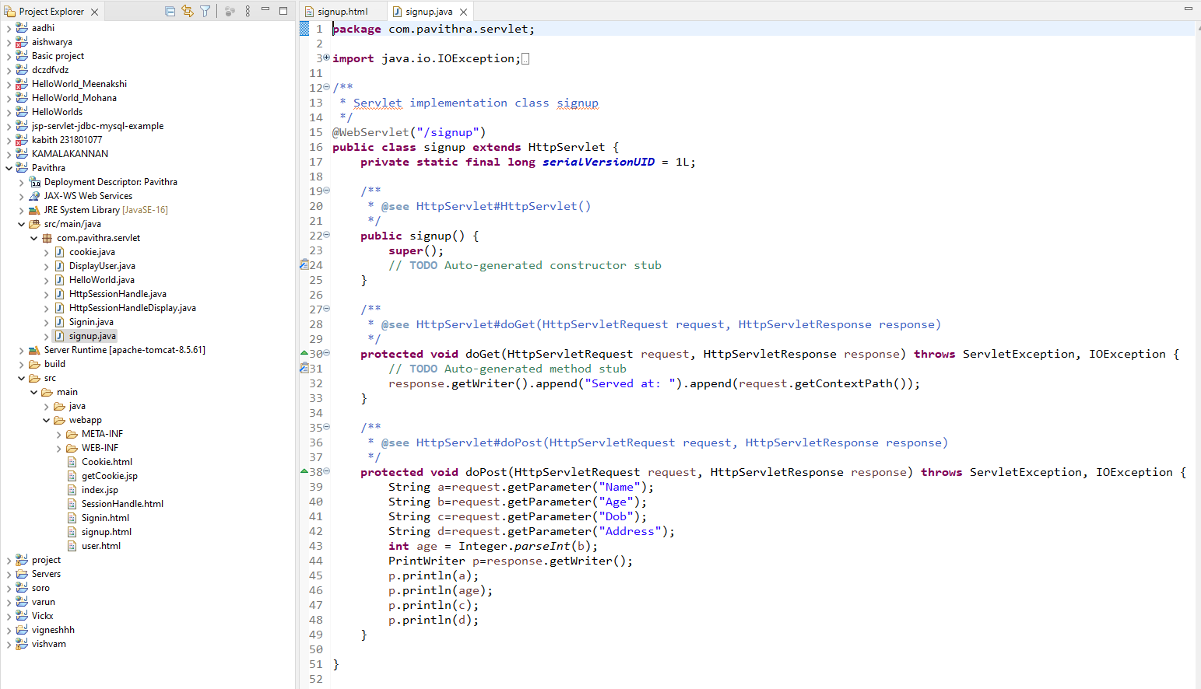

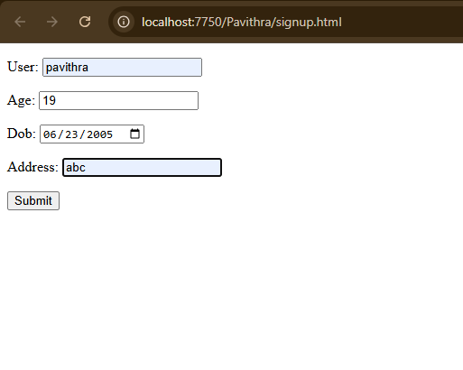

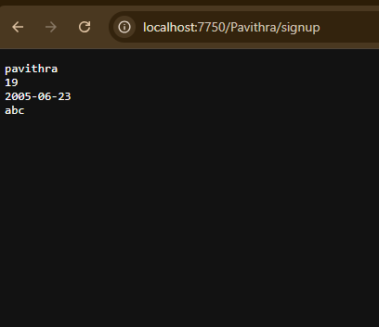

**RESULT:**

Handling signup form using the post method has been Executed Successfully.